**Indices for the pat signal**

1. Predictive value of endothelial function by non-invasive peripheral arterial tonometry for coronary artery disease.

RH-PAT index (RHI)- ratio of average amplitude of the PAT signal over a 1 minute time interval, starting 1.5 minutes after cuff deflation, divided by its average amplitude over a 25 minute time period before cuff inflation (baseline).

1. Peripheral Arterial Tine Assessment (PAT)

Endothelial Index – calculated by creating a post-occlusion to pre-occlusion ratio.

Results:

-PAT score of 2.1 or higher: low risk of heart disease

- PAT score between 1.68 and 2: some lifestyle changes may be necessary.

- PAT score of 1.67 or lower: urgent medical attention.

1. Assessment of endothelial function by non-invasive peripheral arterial tonometry predicts late cardiovascular adverse events.

RH index (L_RHI): ratio between the digital pulse volume during RH and at baseline.

* L_RHI < 0.4: Unhealthy
* L_RHI <>=0.4: comparatively healthy

1. Endothelial function assessed by peripheral arterial tonometry is not related cardiovascular risk score in healthy subjects.

* Reactive Hyperemia index (RHI) : a calculated ratio comparing the pulse wave amplitude during reactive hyperemia to that of the baseline measurement.
* Baseline pulse amplitude: vascular distensibility and digital blood flow.
* Augmentation index: measure of arterial stiffness. Calculated by waveform analysis of PAT signal. Lower AI refers to better arterial elasticity.

1. Augmentation Index derived from peripheral arterial tonometry correlated with cardiovascular risk factors.

$$PAT-AIx=\frac{P2-P1}{P1}\left(\%\right)$$

P1 = pulse pressure

P2 = pressure corresponding to the inflection point

PAT-Aix significantly higher in CAD patients (-5.46±1.7%)

1. Early detection system of vascular disease and its application prospect.

* RHI : ratio of post deflation to baseline pulse amplitude in the hyperemic finger, divided by that in the contralateral finger.

Evaluation of arterial stiffness:

* Pulse wave velocity: measurement of distance and pulse wave transit time between two points of vessels. Carotid femoral pulse wave velocity (CF- PWV) is the gold standard for assessment of large artery stiffness. Measured automatically by ultrasonic equipment or blood vessel detection equipment.
* Cardio Ankel Vascular Index (CAVI): measured by means of arteriosclerosis detection device

1. 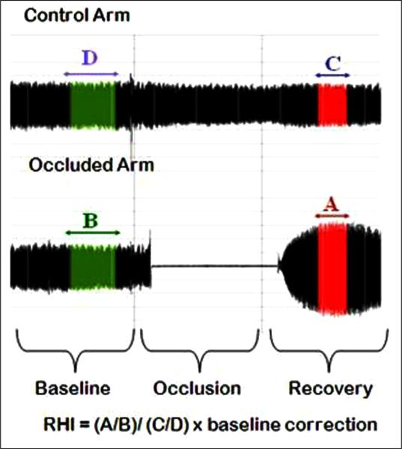Test-retest reliability of pulse amplitude tonometry measures of vascular endothelial function: implications for clinical trial design.

* Reactive hyperemia index: the ratio of the occluded arm’s mean PWA 90-150 seconds post occlusion (A) to the mean PWA from baseline readings of the same arm (B).
* Augmentation Index Scores: measure of arterial stiffness.

**Indices used for the Thermal Signal**

1. 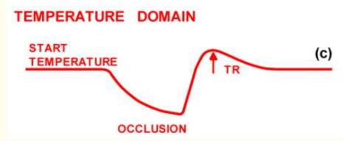Digital thermal monitoring of vascular reactivity closely correlated with Doppler flow velocity



Tfinger(t): time varying finger skin temperature

Hfinger: impulse response formed from the finger time constant

Q2: low frequency mean flow

Convolution.

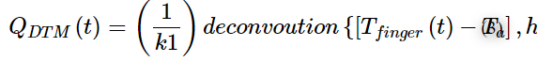Conversion of the temperature signal to flow domains:

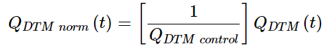

A mathematical derivation of the incremental changes using Poiseuille’s law and first equation through third equation yields insight into the processing.

1. Non-invasive digital thermal monitoring and flow mediated dilation in systemic sclerosis

Temperature Rebound: temperature prior to the cuff inflation subtracted from temperature maximum after cuff relief

Vascular Reactivity Index (VRI) : temperature rebound area under the curve which is provided as a single value of digital thermal measurement.

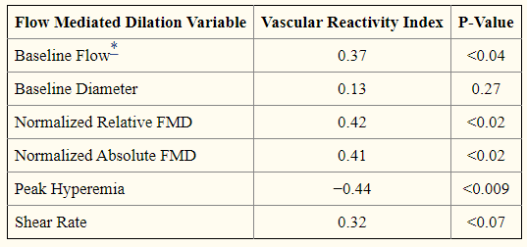

Spearman correlation of FMD measures with VRI: only baseline diameter and flow were not significantly correlated with VRI.